**附加说明：每个部分都是由 时间标题、内容标题、内容组成，放置网站的时候，所有时间标题用一种颜色，所有内容标题用另一种不同的颜色，内容再用一种颜色，【内容】中与其他内容颜色不同的地方也请用与其他内容不同的颜色展现**

**（以上部分不放置到网站中）**

**As early as in 2018**

**Origin and early progress of our project**

As early as in late 2018, we had had some tentative motions and still vague ideas for our 2019 project. It was a time when we collected scattering fragments to gradually form a blueprint for our design. We wrote a simple yet creative program, “**crawlers**”, in designation of finding the research hotspots in recent years which were often correlated with urgent social needs, and found with amazement that the key word “cancer” topped the lists.

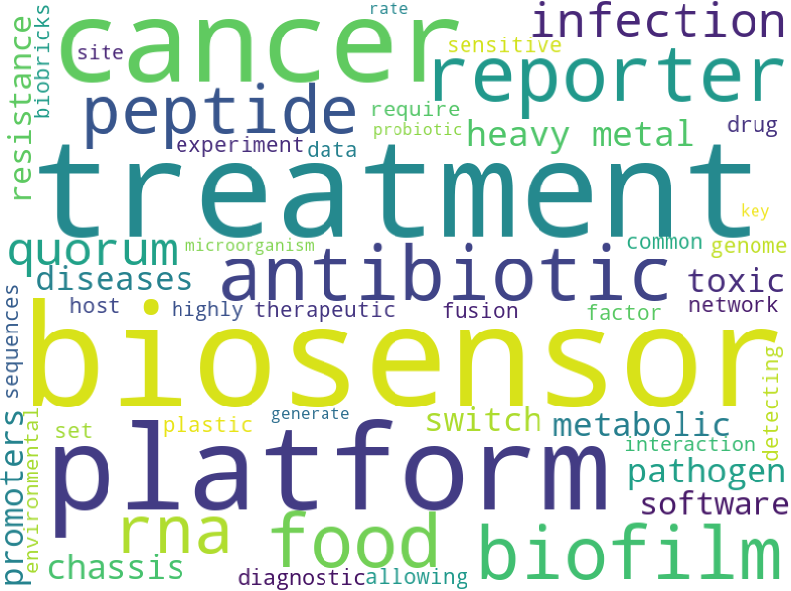

By serendipity, just when we were thinking hard about how to specifically target cancerous cells while doing the least harm to normal tissues, a lecture addressed by Professor Kuang from Hong Kong University of Science and Technology came to our eyes, and inspired us of the possibilities of using different miRNA expression levels in different organisms to serve as a “identification card” in distinguishing mutated cells from normal tissues. Moreover, a push notification from a scientific official account, reporting a recent research on the application and advantages of oncolytic virus in cancer therapy caught our attention. A wild idea of combining specific miRNAs as response elements with other regulatory molecular switches, and ultimately using the oncolytic virus as our circuits’ carrier, gradually came into beings.

**April**

**Brainstorm sparkled wisdoms**

We considered using miRNAs as response elements and adenovirus as pathway’s carrier a great idea for cancer recognition and treatment, but we didn’t want to be hasty into coming to a decision. As early as this April, we had a general and thorough debate over our project, going into details for experimental verification, brainstorming and exchanging ideas on the feasibility and possible impacts of our design to real-world situations. We asked ourselves:

1. What is the status quo for cancer therapy? Is it efficient enough or have it reached a bottleneck?
2. What are public’s recognitions and opinions towards current cancer therapy? What do people genuinely care about?
3. Would the word “virus” in our project, under stereotype effect, results in public panic? If so, how can we erase such stereotype and introduce our project to the real-world application?
4. Is our design precise enough? How would specificity be guaranteed in the miRNA profile once selected?

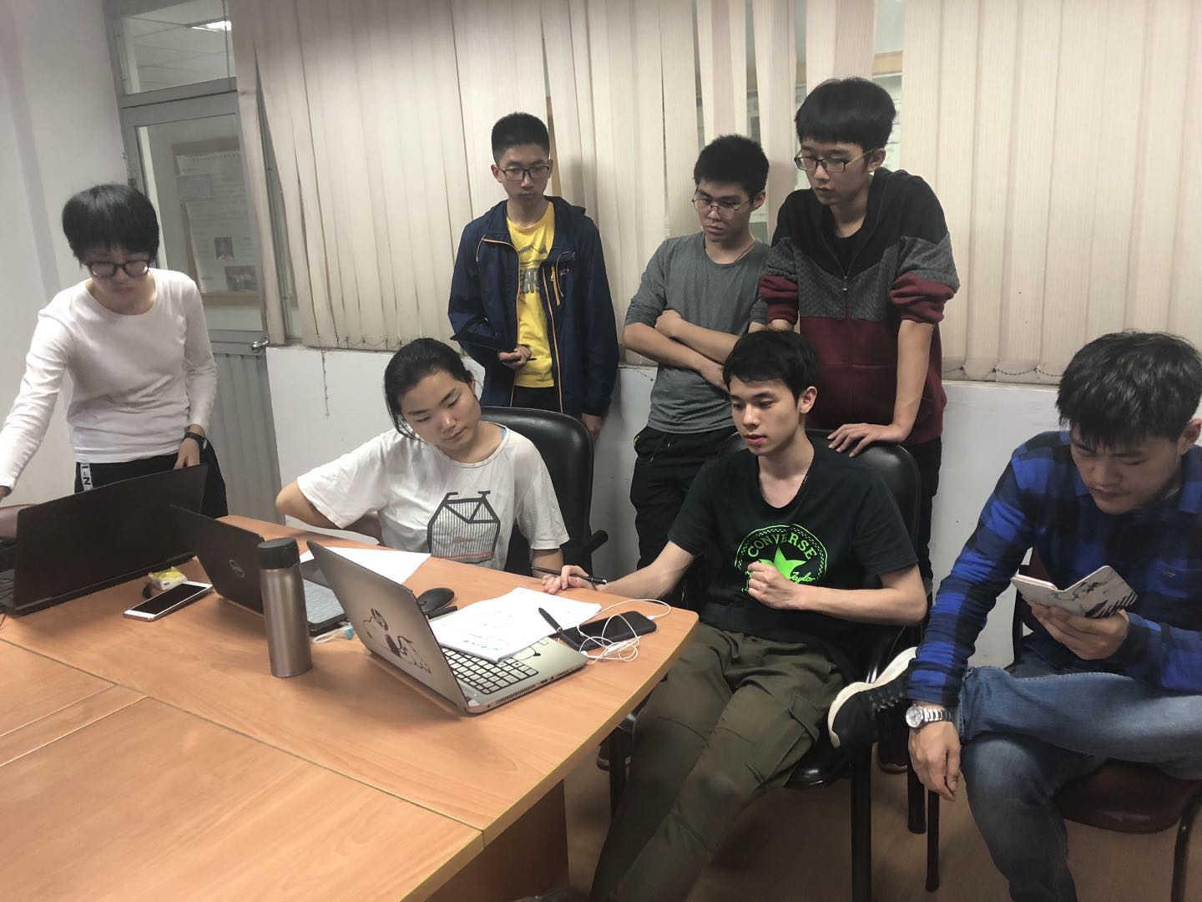

Guided by these questions, we sorted ourselves into small work groups, and sprung into actions in mainly three directions, clinical frontiers, the public and research frontline in correspondence to our put-forth doubts. This meeting laid the foundation for our future human practice activities and frequent engagements with societies. And all our efforts proved to be very fruitful in assistance of the development of our project.

**April**

**Our first visit to Dr. Huang Rongkang**

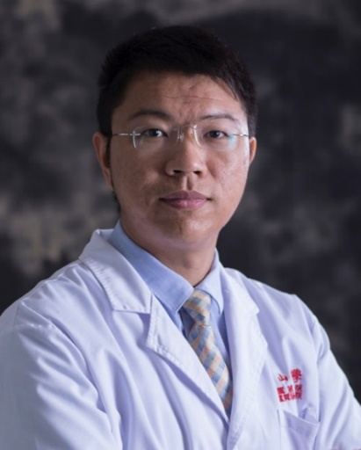We conducted an interview with Dr. Huang Rongkang from the sixth affiliated hospital, SYSU who has about a decade of rich experience in colon and rectal clinical therapy. We hoped to get a better understanding of the current situations and dilemmas against cancer therapy and we were not disappointed. From Dr. Huang, we got to learned that the colorectal cancer’s development can be divided into 4 stages and there are corresponding therapeutic methods under different situations. Even with such routinizations, however, current methods in cancer treatment were not that promising as indicated by the five-year survival rate, and it was mainly attributed to an insufficient amount of specificity in telling the cancerous cells apart from normal tissues, which would lead to serious toxic and side effects, according to Dr. Huang.

Higher specificity has been our main purpose ever since our project originally started, and Dr. Huang’s descriptions made us even more resolute into resolving this issue. Motivated by Dr. Huang, we decided to put our focus on colon cancer, which in today is still one of the most commonly-seen and serious malignant tumors in digestive system with an average five-year survival rate of only mere 40%. Our following work of filtering the specific miRNA profile on TCGA, as guided by Dr. Zheng Lingling from the School of Life Science, SYSU, was built on this.

**May**

**Ambassador Zhang at South China Regional Meeting**

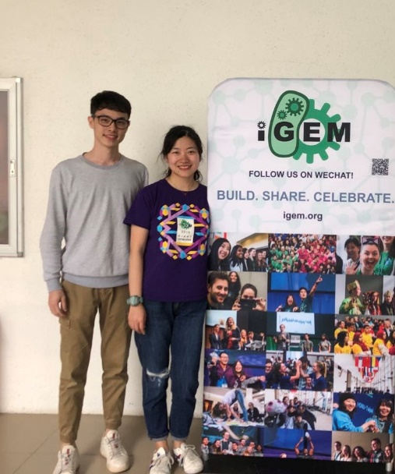 We had long thought about collecting opinions and perspectives from the public, who are probably the most vital stakeholders of our project. We had designed a questionnaire with special attentions, ready to release in late April. It just so happened and quite fortunately indeed, that we attended the iGEM Southern China Regional Meeting where ambassador Dorothy Zhang, iGEM Regional ambassador for Asia in the 6th CCiC (Conference of China iGEMer Community), kindly advised us to consult specialists before posting the questionnaire, for the sake of ethical safety. It gave us head reminder to draw rein on our intended public investigation. Guided by this, we contacted Professor Tien Ming Lee at the School of Life Science, SYSU, for more details into the questionnaire design.

**May**

**A visit to Professor Tien Ming Lee**

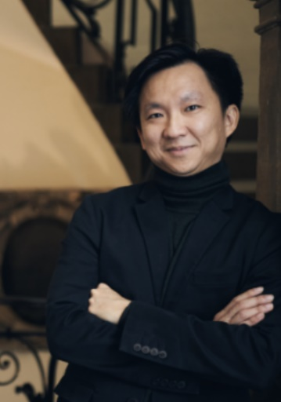In order to investigate public’s opinions and propensity on current cancer therapies, we carefully designed a social questionnaire in late April. Most coincidently and luckily, we came across with ambassador Dorothy Zhang who suggested that we’d better consult an expert in advance. Therefore, we made a consultation with Tien Ming Lee at the School of Life Science, SYSU, a social and ecological protection expert who is especially good at conducting social investigations. After scrutinizing our original questionnaire, he patiently made several suggestions, which underlaid our progress in questionnaire designing. The followings are our big harvests:

(1) Given the ethical concerns, cancer patients are not encouraged to be included while investigating. The proper objects for the investigation should be common individuals, doctors, nursing workers at hospitals, friends and relatives of the patients.

Taking patients’ and their relatives’ emotions into consideration, we set a logic skip. If the cancer patients come across with our questionnaire and pressed the button, “I am a cancer patient”, the web page would directly skip to the thank-you page.

(2) Design a series of questions to euphemistically ask respondents who might be close to some cancer patients to find out whether the treatment the patient receives is effective.

We added a question, that is “Do you or someone close to you have cancer?” If the answer is “Yes”, a logic skip would be triggered and the following questions would be: “What kinds of treatment did you/he (the cancer patient) adopt?” and “what is the current treatment effect of you/him (cancer patients)?” Professor Lee advised us to set this series of logic questions to learn what are the most commonly used cancer therapies and their effectiveness.

(3) Pay extra attention to people’s concerns in cancer therapy, from which we might extract some sally points to settle such concerns.

We set several questions after Prof. Lee’s suggestions to investigate what do the public concern in current and novel cancer therapies, and which methods would one choose if he had cancer. The following questions were added in the second edition:

1. What are the factors that you concern when choosing a cancer therapy? Sort the follow possible factors as you see fit.

2. What concerns do you have about oncolytic virus therapy to treat cancer?

(4) Use some specific method such as **Control Preferences Scale** to analyze therapeutic choice tendency when an object is assumed to get either a slight illness or a more serious illness.

The Control Preferences Scale (CPS) was developed to measure a construct that emerged from a grounded theory of how treatment decisions are made among people with life-threatening illnesses. A scale of preference can be defined as the list of wants or needs that a person writes or comes up with in the order of importance. (Click here to obtain the full article of The Control Preferences Scale[1])

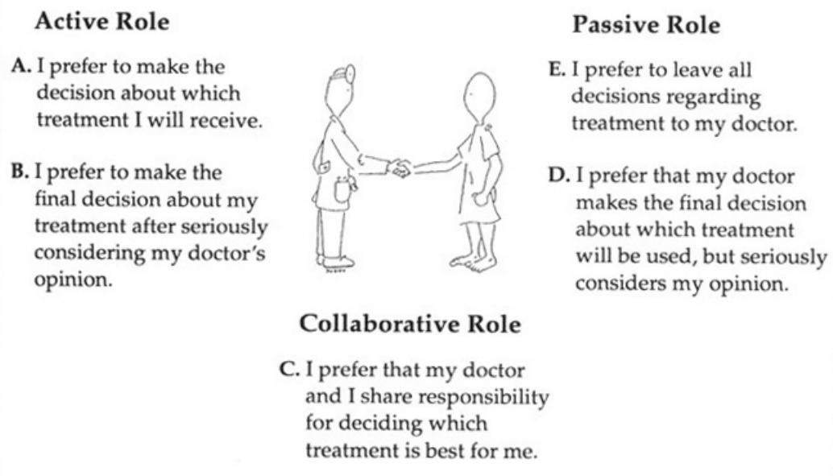

The graphic vividly shows 5 possible choices in the “Selection of the Measurement Model”. From option A to E, one’s willingness of actively deciding the treatment scheme declines as more power is resided to his physician. CPS is one of our biggest gains when interviewing Prof. Lee. We applied this skill into our questionnaire, setting a couple of questions for two different situations: “When you go to a doctor for a ‘slight disease’ (such as common), how would you prefer to decide your treatment?” and “When you go to a doctor with a ‘serious disease’ (such as cancer), how would you prefer to decide your treatment?” We found with amazement that patients are more willing to raise doctors’ power of decision in face of more serious illnesses.

(5) The “superiority effect” in the questionnaire should be reduced to minimum.

Prof. Lee gave us well-intentioned warnings concerning superiority effect. Therefore, we make a little adjustment to the orders of our questions. We moved the questions related to oncolytic virus backward in case of giving preconceptions from prior information to respondents. In addition, we delete some questions that might be misleading. We also gave a brief introduction to the oncolytic virus therapy in ahead of relevant questions to ensure respondents with enough information to objectively answer the following questions.

(6) Consult relevant experts on how to explain the benefits and possible side effects of our project to patients by leaving our stereotype effects.

Even though Prof. Lee had given us many suggestions to reduce potential ethical risks and make our questionnaire more logical, he couldn’t answer for sure how to introduce our project, pros and cons simultaneously, to the public and patients with cancer. He advised us to further consult other specialists, such as clinical doctors. In light of this, we paid Dr. Huang Rongkang a second visit afterwards.

After reflecting on Lee’s advice, we refined our questionnaire over the original version (Click here for the first edition of our questionnaire) with less ethical concerns, more precise and accurate words and sentences, and more logics and considerations. We put forth the second edition of our questionnaire shortly afterwards (Click here for the second edition of our questionnaire). This new version of questionnaire have brought us valuable data on public’s opinions with respect to current strategies in treating cancer, their mentality in making therapeutic decisions, and their concerns in cancer therapy.

**June**

**Higher security for our project**

We interviewed Associate Professor, Dr. Jiang Songshan at the School of Life Science, SYSU, a specialist in the field of dysregulation of miRNA and correlated tumor disease. He pointed out in scrutiny his concerns in the specificity of the selected miRNA profile. After our explanation to him of how we chose the miRNA-592 and miRNA-885-5p in the first place, he advised us to check once again whether this combination was specific enough. He raised the possibility that the miRNA expression levels could differ from cells to cells, tissues to tissues, even individuals to individuals, and that we should think harder into this aspect.

After consulting Dr. Jiang, we checked the tissue specificity of the miRNA expressions, and found with surprise that the miRNA expression levels of the colon cancer cells and male sperm cells were quite similar. From our previous filtering, miRNA-592 showed high expression level in colon cancer cells, and miRNA-885-5p was lowly expressed in colon cancer cells. We designed double rejection circuit and direct rejection circuit for miR-592 and miR-885-5p respectively. In light of the similar expression profile in sperm cells, we added an expression-deficient miRNA, miRNA-663b, into our circuit right next to the coding sequence of our engineered viral capsid gene, without whose existence can the downstream pathway be activated and viral capsid successfully constructed.

**September**

**Our second visit to Dr. Huang Rongkang**

Our second visit to Dr. Huang at the sixth affiliated hospital, SYSU, was accompanied with a more mature and well-designed project. During the interview, Dr. Huang introduced to us the common three processes necessary before a new therapeutic method could be applied in a large scale, and untied the knot of our worries about the future promotion of our project.

Another big harvest we gained in our second visit was the amendment of our drug-delivery methods. In our original design, we wanted to use enema or suppository, which based on our former understanding could continuously dose medicine to target intestinal regions. But Dr. Huang, from his rich clinical experience, said that even though enema and suppository are very good ways for continuous and local dosing, their spheres of influence and time effects are limited. He then showed us a graphic of intestine structures on his laptop and pointed out that dosing with enema or suppository can only function around the anus zone and little rectum. In addition, the treatment time wouldn’t last long since patients would feel uncomfortable and defecate the drug liquid in no more than 30 minutes.

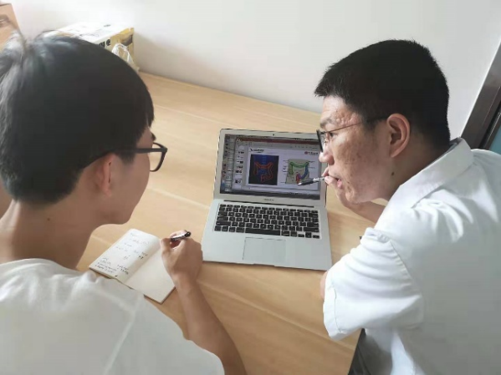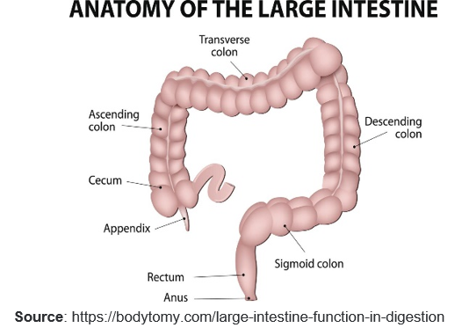

Inspired by Dr. Huang, we decided to dig deeper into this aspect into finding a more proper way of drug dosing. We collected more information in search of a better drug delivery method and found with amazement in a 2019 journal [2] published on Science a new method using hydrogel in drug dosing. As shown in the table, hydrogel is relatively stable and has high biological compatibility. It can realize a more exquisite and precise drug dosing regulation with longer treatment time, compared to enema and suppository. Though still under experiment examinations, it might as well be a proper way for drug delivery for future possible application.

|  |  |
| --- | --- |
| Administration modes | Pros and Cons |
| Enema | It can be applied for emergence detoxing and removing wastes, but it might do harm to intestinal flora and affect defecation reflex. |
| Suppository | It avoids the loss of function for drugs from gastrointestinal pH and enzymes, but its drug loading and function zone is limited with too short a treatment time. |
| Hydrogel | It can realize stable administration for longer time with larger administration area. It’s a new type of biological material, which can realize finer control over drug delivery by modifying the combination of ssDNA and dsDNA and the crosslinking degree of hydrogel [3]. |
| Intestinal stents | It has excellent biocompatibility and corrosion resistance, as well as memory characteristics and super-elasticity. However, it’s easily shifted and deformed, which might do damage to large intestines, even resulting in stent migration, bleeding and abdominal pain [4]. |
| Oral capsules | It easy for patients to take in medicine, but its target is not accurate enough which can easily lead to large amounts of wasting and toxic side effects. |

**Summary**

The social influence and possible risks of our project have always been our major concern. We dug deep into this aspect by frequently involving with potential stakeholders and experts in relevant fields for a safer and more responsible application. Our project was originally inspired by fragmented evidence, aiming at research hotspots, which in our believe is tightly bound to urgent social needs. From our analysis in early April, 2019, we identified clinical feasibility, public acceptance and higher safety as our main focus in relation with society, and we have been working on this accordingly all through the progress of our project.

In the first edition of our design, we had planned to construct miRNA-592 and miRNA-885-5p to serve as rejection circuits to specifically respond to colon cancer cells, and to use enema or suppository for drug administration. We were concerned about the propagation issue of our oncolytic virus therapy, worrying that it might result in public panic. It was not until our long endeavors into associating with doctors at clinical frontline and experts at scientific cutting edge, and connecting with common people through questionnaire, which had been elaborately re-modified by Professor Lee’s kind suggestions, had we resolved our doubts and obstacles one after another.

Back when we put forth the second edition of our project, we added a new miRNA-663b with expression deficiency in colon cancer cells into the circuits, altered our plan for administration from enema or suppository to hydrogel or other methods with longer time effect and higher localization. We were glad to see that our puzzles and worries were gradually wiped out in our way of explorations and negotiations with different aspects, and that our project have made big progress from the original wide idea to a more mature figure with the possibility of being applied in the future. At elementary stage, we still have a long way to go before fully propagating and applying our design in real-life therapy. Even so, we would continuously dedicate our efforts, and hope as well as strive for an early emergence of new therapeutic methods against cancer.

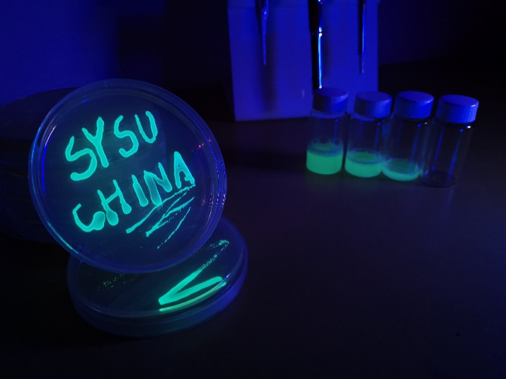

[1] Lesley F. Degner, Jeff A Sloan, Peri Venkatesh. “The Control Preferences Scale.” Canadian Journal of Nursing Research. 3: 21-43(1997)

[2] English, Max A., et al. "Programmable CRISPR-responsive smart materials." *Science* 365.6455 (2019): 780-785.

[3] Sepantafar, Mohammadmajid, et al. “Engineered Hydrogels in Cancer Therapy and Diagnosis.” Trends in Biotechnology 35.11(2017).

[4] Park, Semi , et al. "Benefits of Recurrent Colonic Stent Insertion in a Patient with Advanced Gastric Cancer with Carcinomatosis Causing Colonic Obstruction." Yonsei Medical Journal 50.2(2009).